**IMGS-351**

**Project 1 report**

**Team #: 1**

**Names: Cooper White & Gian-Mateo Tifone**

**Date: 9/11/2023**

Make/model of camera used to take images: iPhone 13 Pro Max

Camera settings (if applicable): N/A

Image of ColorChecker chart and color patches from step 3)

Cropped/resized image of ColorChecker chart from step 4)

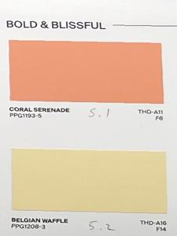Cropped/resized image of color patches from step 4)

Matlab script from step 4)

% proj1.m

% Reads colorchecker and color sample images

% Performs: rotate, crop, resize

% Saves separate colorchecker and sample images

% 9/11/2023 CW & GMT

%Read in colorchecker + sample image

colorChecker=imread('white_iPhone13.jpg');

%Define bounding recrangle for crop

rect=[850 600 1800 1250];

%Crop colorchecker

colorChecker_c=imcrop(colorChecker,rect);

%Resize colorchcecker

colorChecker_r=imresize(colorChecker_c, [800 1125]);

%Define bounding rectangle for crop

rect=[2750 1260 380 625];

%Rotate samples

colorChecker_rotated=imrotate(colorChecker,-1,'crop');

%Crop samples

samples_c=imcrop(colorChecker_rotated, rect);

%Resize samples

samples_r=imresize(samples_c, [300 225]);

%Save separate colorchcker and sample images as JPG's

imwrite(colorChecker_r,"chart.jpg");

imwrite(samples_r,"samples.jpg");

Real/imaged ColorChecker charts in lightbooth from step 6)

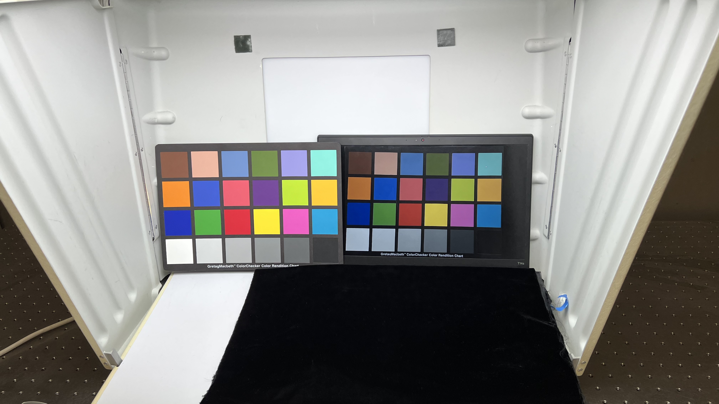

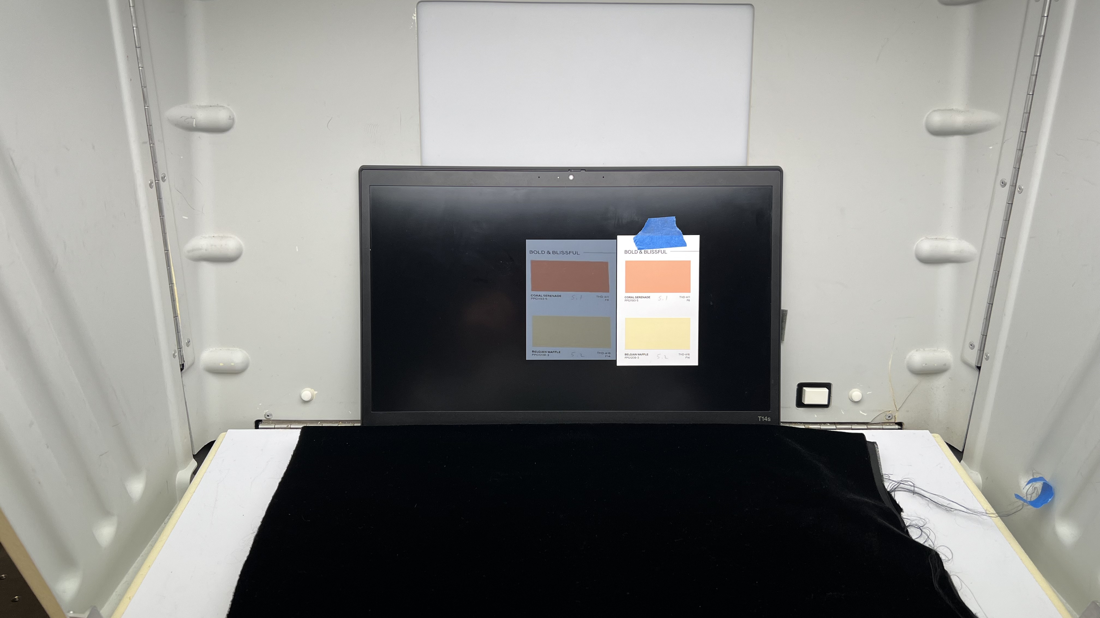Real/imaged color patches in lightbooth from step 6)

Table of visual color differences between real/imaged patches from step 6)

**Reflection**

Cooper White created the code. Cooper and Gian-Mateo made color comparisons about visual color differences between the real and imaged color checker. Gian-Mateo did the report.